 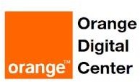

Session 1

28-08-2022

# Basics:

Content

1. **Programming**
2. **Data Structures**
3. **Algorithms**
4. **OOP**
5. Software Engineering
6. Operating systems
7. System Analysis
8. Database
9. Network

# Programming Languages Types:

* High level
* Low level
* Compiled
* Interpreted
* Programming
* Scripted
* Open source
* Not open source
* Support OOP
* Not supporting OOP
* Typed
* Not typed
* General purpose
* Specific purpose



# Tasks

## Task 1

**What is OOD? who use it? why we use it?**

Object Oriented Design is a conceptual model for the architecture of object-oriented software, forces programmers to plan and organize their code.

Software Engineer who uses it, design software that has a low cost of change

## Task 2

**What is the operating system core language?**

|  |  |
| --- | --- |
| OS | Language |
| Windows | kernel is developed mostly in C, with some parts in assembly language |
| Linux | Linux is also written mostly in C, with some parts in assembly. |
| MAC | Mac computers are also powered by C, since the OS X kernel is written mostly in C. |
| Mobile | iOS, Android and Windows Phone kernels are also written in C |

## Task 3

**What are the first 10 programming languages appeared?**

Matlab,Ada, Assembly Language,SQL,smalltalk,Pascal,Basic,cobol,Lisp,Fortran

## Task 4

**What are the type of languages that we could use in giving instructions?**

Procedural languages

Procedural languages are based on the data viewing range of a code statement. Examples include Ada, BASIC, C/C++ and JavaScript.

Functional languages

Functional languages use stored data to perform recursive functions, which execute a process and then repeat it to solve any errors that arise during programming. Examples include Agda, Cuneiform, PureScript and APL.

Machine languages

Machine languages are made up of binary code, which is a series 0s and 1s that symbolize text or instructions for a computer program. One example of a machine language is Fortran.

Assembly languages

Assembly languages work in a similar way to machine languages by using short mnemonic codes to give the computer instructions. Examples include Lotus 1-2-3 and Turbo Pascal.

Logic programming languages

Logic programming languages add restrictions to statements made by developers that cause the computer to consider the possible outcomes of different actions. Examples include Prolog, ASP and Datalog.

Data-oriented languages

Data-oriented languages offer different ways to search and edit entity-relationship tables. Examples include Clarion, Gremlin, WebDNA and Wolfram Language.

Business-oriented languages

Companies use business-oriented languages to work with large quantities of data across a variety of different systems. Examples include SQL and COBOL.

Object-oriented languages

Object-oriented language identifies everything it encounters as objects that have internal and external data and then it performs based on moving these "objects" to where they need to be. Examples include Java, Visual Basic .NET, Ruby and Python.

Scripting languages

Scripting languages solve smaller programming issues and can be used to write operating system utilities. Examples include Perl, PHP, JavaScript and Python.

World Wide Web display languages

World Wide Web display languages are used to design web pages and provide them with the desired functions, such as page retrieval through links. Examples include HTML, XML and CGI.

Front end coding languages

Front end development languages are used to code the visual aspects of websites, games, software and apps. Examples include HTML, CSS and JavaScript.

Database programming languages

Database programming languages help to create databases and manipulate the way data is stored inside them. Examples include C++, COBOL, Java and Perl.

Rule-based languages

Rule-based languages implement rules once they are activated by certain conditions in a data set. Examples include AWK, CLIPS, Prolog and Wolfram Language.

Compiled languages

Compiled languages have been translated by computer programs from one programming language to another and convert information directly to code, which streamlines the programming process. Examples include ActionScript, Ballerina, C++ and ALGOL.

Back end coding languages

Back end coding languages code program servers so that web pages appear and function correctly. Examples include Python, Java and Ruby.

System languages

System languages can complete tasks like memory management or task management when programming an entire system. Examples include Swift, Rust, C++ and Nim.

Algorithmic languages

Algorithmic languages convey mathematical or symbolic computations and can use algebraic operations to convey information. Examples include Fortran, ALGOL, Lisp and C.

Command-line interface languages

Command-line interface languages use lines of text to send commands to computer programs. Examples include Batch, CLIST, TACL and 4DOS

## Task 5

**What is the new programming language that have the same syntax of python and as fast as C?**

The Peregrine programming language

## Task 6

**List 1o programming languages open source and 10 not open source**

|  |  |
| --- | --- |
| Open Source | Not-Open Source |
| 1.JavaScript  2.Python  3.PHP  4.Swift  5.R Programming  6.C++  7.Go  8.Kotlin  9.Scala  10.Ruby | VBScript  C#  MATLAB  COBOL  IBM’s mainframe  AIX  JAVA |

## Task 7

**What are JavaScript advantages?**

It is considered as a link between Front End and Back End

## Task 8

**What is fragmentation?**

Fragmentation is an unwanted problem where the memory blocks cannot be allocated to the processes due to their small size and the blocks remain unused. It can also be understood as when the processes are loaded and removed from the memory they create free space or hole in the memory and these small blocks cannot be allocated to new upcoming processes and results in inefficient use of memory. Basically, there are two types of fragmentation:

* External Fragmentation

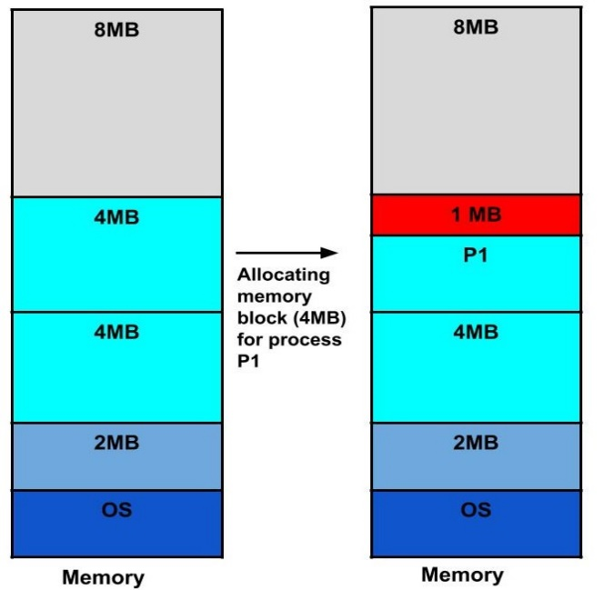

* Internal Fragmentation

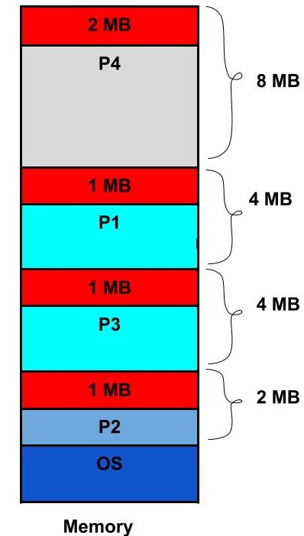

# Programs to be downloaded:

1. Anaconda
2. Cmder
3. Git Bash
4. Postman